**ITT-216 VPN Configuration**

Students Name

Institution of Affiliation

Professor’s Name

Course Number and code

Date of Submission

**ITT-216 VPN Configuration**

**Introduction**

In today's interconnected world, organizations rely heavily on secure and efficient communication networks to facilitate their operations. With the continuous growth and expansion of businesses, the need for establishing secure connections between remote locations and the main office has become paramount. This is where Virtual Private Networks (VPNs) play a crucial role.

The purpose of this project is to enhance the existing network infrastructure by implementing a VPN solution. By setting up VPNs, organizations can create secure and private communication channels over public networks, ensuring the confidentiality, integrity, and availability of data transmitted between locations. This project focuses on configuring and establishing VPN connections between the main office and new location sites.

The implementation of VPNs offers several benefits, including secure data transmission, enhanced privacy, and improved network connectivity. By leveraging VPN technology, organizations can securely exchange sensitive information, access shared resources, and maintain seamless communication across geographically dispersed locations. Additionally, VPNs provide a cost-effective alternative to dedicated leased lines, as they utilize existing internet connections while ensuring the privacy of transmitted data.

Throughout this project, we will use Packet Tracer, a network simulation tool, to configure and test the VPN connections. By following a series of step-by-step instructions, we will replace existing routers, establish VPN tunnels, perform connectivity tests, and document the network changes for management review.

By successfully completing this project, organizations can strengthen their network infrastructure, enable secure remote access for employees, and foster efficient communication between different locations. The implementation of VPNs not only enhances security but also contributes to streamlined operations, improved collaboration, and optimized resource utilization.

**Summary of network changes for management**

In order to enhance the network infrastructure and establish secure communication channels between the main office and remote locations, several network changes have been implemented. Each change has been carefully selected to address specific requirements and improve the overall network performance. The following is a summary of the network changes along with their rationales and intended benefits:

1. ***Replacement of Routers***

The existing Home-Office-Router has been replaced with a new Cisco 2811 router named Main-Office-VPN-Router.

1. The NewLocation routers have been replaced with Cisco 1941 routers.
2. *Rationale:* The previous routers were not equipped with the necessary features and capabilities to establish VPN connections. By replacing them with more suitable models, we ensure compatibility and enable the configuration of VPN tunnels.
3. *Benefits:* The new routers provide enhanced VPN functionality, increased performance, and improved security measures, thereby facilitating secure communication between the main office and remote locations.
4. ***Configuration of VPN Tunnels***
5. VPN tunnels have been configured between the Main-Office-VPN-Router and each of the NewLocation routers.
6. ISAKMP policies, pre-shared keys, and IPsec transform sets have been defined for each VPN connection.
7. Crypto maps have been created to specify the peer IP addresses, transform sets, and access control lists (ACLs) for split tunneling.
8. *The Rationale:* VPN tunnels establish secure and encrypted communication channels, ensuring the confidentiality and integrity of data transmitted between locations. Configuring VPN tunnels enables remote offices to securely connect to the main office network and access shared resources.
9. *Benefits:* The VPN tunnels provide a secure and private connection over public networks, protecting sensitive data from unauthorized access. This enhances data privacy, mitigates the risk of interception or tampering, and enables seamless and secure communication between remote locations and the main office.

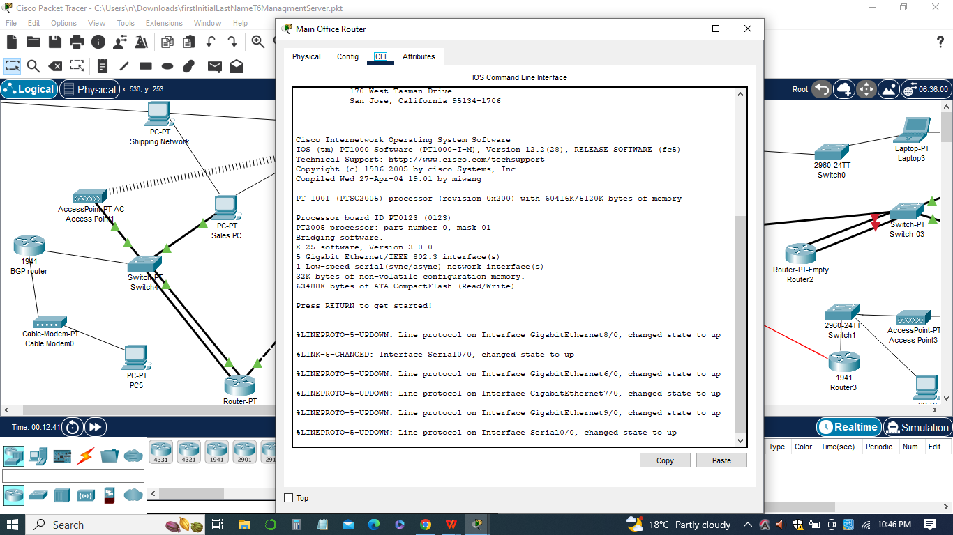

1. ***Improvement of Network Connectivity and Data Privacy***

Serial connections have been moved from the Main-Office-Router to the Main-Office-VPN-Router. EIGRP has been updated on both routers to ensure proper routing between the main office and remote locations.

1. *Rationale:* By relocating the serial connections to the Main-Office-VPN-Router, we establish direct connectivity between the main office and the VPN router, enabling efficient data transmission and reducing latency.
2. *Benefits:* The improved network connectivity results in faster and more reliable communication between the main office and remote locations. Additionally, updating the routing protocol ensures proper routing and seamless data transfer, enhancing overall network performance.

The above network changes described are aimed at strengthening the network infrastructure, establishing secure VPN connections, and improving network connectivity and data privacy. These changes enable secure remote access, enhance collaboration between different locations, and optimize resource utilization. By implementing these network enhancements, organizations can ensure the confidentiality and integrity of their data, streamline operations, and foster efficient communication between geographically dispersed locations.

**List of ping**

The list of pings is an essential part of the network assessment process to verify the connectivity and functionality of the network after implementing the network changes. In this scenario, the list of pings involves sending ICMP (Internet Control Message Protocol) echo requests from a workstation to various network devices and locations. The purpose is to validate the successful establishment of network connections and the proper functioning of network services. Here are the key aspects of the list of pings used:

1. ***Workstation-to-Device Pings:***

* Pinging from the workstation on Switch-01 in the main location to each of the ports of the network devices, including routers and switches. This ensures that the connections between the workstation and these devices are functioning correctly.
* By pinging the devices, it can be confirmed whether they are reachable and responding to ICMP echo requests. Successful pings indicate that the devices are online and accessible.

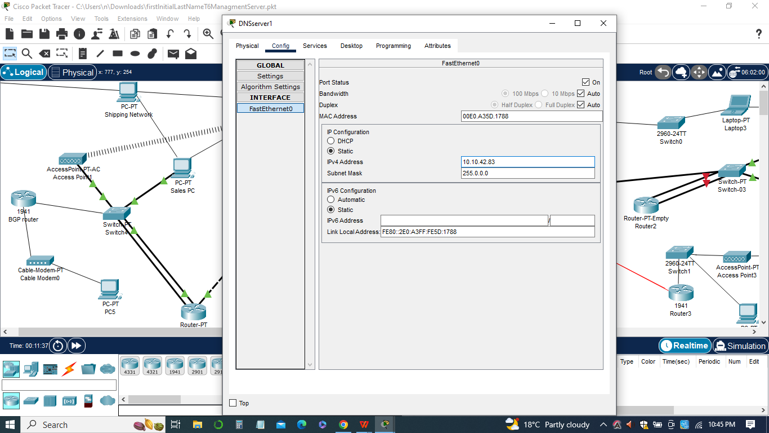

1. ***Workstation-to-Location Pings:***

* Pinging from the workstation on Switch-01 in the main location to the Sales workstation in each of the remote locations (NewLocation1, NewLocation2, etc.).
* The purpose of these pings is to test the connectivity between the main location and the remote locations, specifically to the Sales workstation in each location.
* Successful pings confirm that the VPN tunnels and network connections between the main location and the remote locations are properly established and functioning.

1. ***Pings from Other Locations:***

* It is implied that pinging from other workstations or devices in the network to various locations will also be performed.
* These pings help assess the overall connectivity and reachability of the network from different points of origin within the network.
* The results of the pings, whether successful or unsuccessful, provide valuable insights into the network's performance, connectivity, and any potential issues that need to be addressed. Any failed pings can indicate network connectivity problems, misconfigurations, or potential firewall or ACL restrictions. Conversely, successful pings validate the successful implementation of network changes and the establishment of secure VPN connections.

In sum, the list of pings plays a crucial role in evaluating the effectiveness of the network changes, ensuring proper connectivity, and identifying any potential areas that require further attention or troubleshooting.

**Ping configurations**

The ping configurations are a set of commands and parameters used to perform network diagnostics and test connectivity between network devices. In the context of the given scenario, the ping configurations involve sending ICMP echo requests from a workstation to various devices and locations in the network. Here are the key aspects of the ping configurations:

***Source and Destination IP Addresses***

1. The source IP address is the IP address of the workstation or device from which the ping is initiated.
2. The destination IP address is the IP address of the target device or location to which the ping is sent.

***Ping Command***

The ping command is used to initiate the ICMP echo requests and receive corresponding echo replies.

The command typically follows the syntax: ping

***Ping Parameters***

The ping command may be supplemented with additional parameters to control the behavior and characteristics of the ping operation. Some commonly used parameters include



1. Number of ICMP echo requests to send (-c ): Specifies the number of echo requests to send to the destination.
2. Timeout duration (-t ): Sets the time duration after which a ping request is considered timed out if no response is received.
3. Packet size (-s ): Specifies the size of the ICMP echo request packets.
4. Time-to-Live (-T ): Sets the maximum number of hops (routers) that a ping request can traverse before being discarded.

***Interpretation of Ping Results***

1. A successful ping is indicated by the receipt of ICMP echo replies from the target device or location.
2. The round-trip time (RTT) is typically displayed for each ICMP echo reply, indicating the time taken for the request to reach the destination and the reply to return.



1. If the ping is unsuccessful, it may indicate network connectivity issues, device misconfigurations, firewall restrictions, or other network problems.
2. In the given scenario, the list of pings would involve performing ping commands from the workstation on Switch-01 to various devices and locations, such as the ports of network devices and the Sales workstation in each remote location. The ping configurations may include specifying the destination IP addresses, setting the number of echo requests, adjusting timeout durations, and analyzing the ping results.

By performing these ping configurations, network administrators can assess the connectivity and responsiveness of the network, troubleshoot potential issues, and ensure that the network changes and VPN configurations are functioning as intended. Any failed pings can indicate areas that require further investigation and troubleshooting to maintain a reliable and efficient network.

**Configurations**

The configurations for setting up the VPN and network changes involve several steps to ensure proper connectivity, security, and data privacy. Here are the key configurations that need to be implemented:

***Router Replacements***

1. The existing routers in the network, such as the Home-Office-Router and NewLocation routers, are replaced with more suitable models, specifically the Cisco 2811 for the Main-Office-VPN-Router and Cisco 1941 routers for the NewLocation routers.
2. The rationale behind this change is to enable VPN configurations between the Main-Office-VPN-Router and the NewLocation routers, allowing secure communication between the sites.
3. The new routers are configured with the same addresses and routing protocols as the old routers to maintain network consistency.

***IOS Update***

1. The Cisco 1941 routers require an IOS update to version 15-k9 to ensure compatibility with the VPN configurations.
2. The update is performed using TFTP (Trivial File Transfer Protocol) and the TFTP server set up on server 10.10.42.82.
3. This update enhances the routers' functionality and compatibility with the VPN setup.

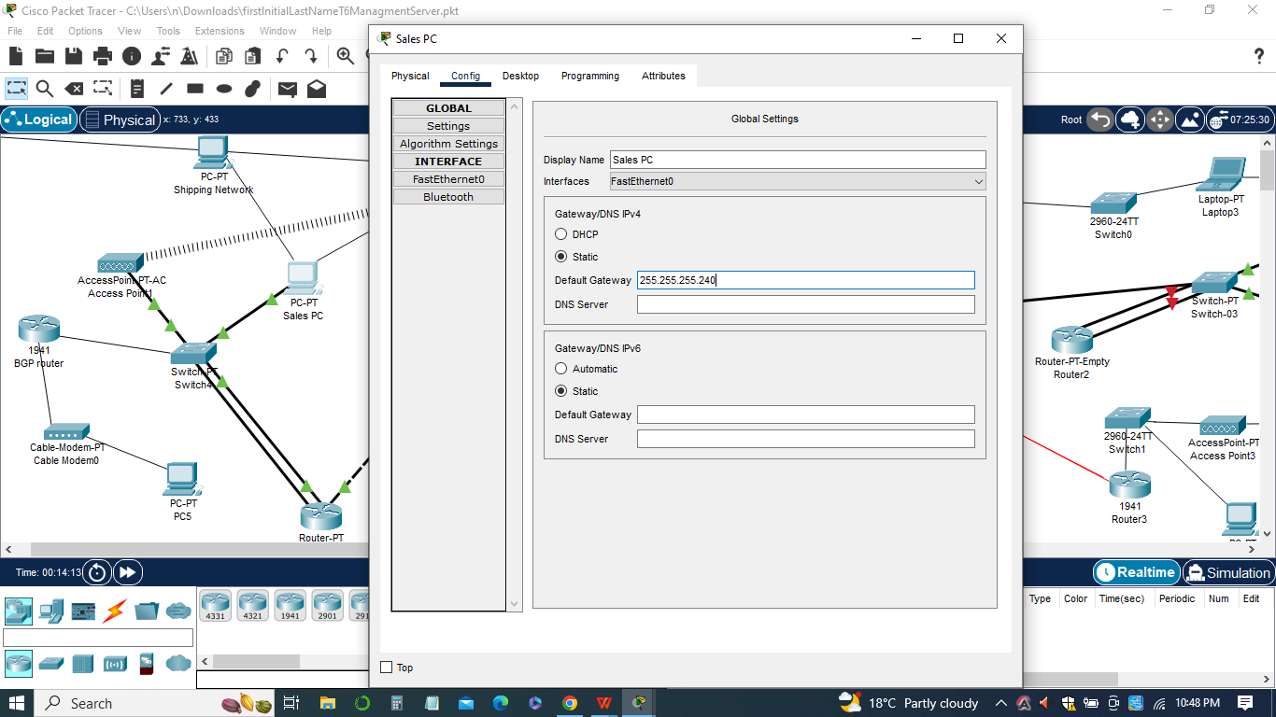

***VPN Configuration***

1. VPN (Virtual Private Network) configurations are implemented to establish secure communication between the Main-Office-VPN-Router and the NewLocation routers.
2. ISAKMP (Internet Security Association and Key Management Protocol) policies are created to handle Phase 1 negotiations for the L2L (LAN-to-LAN) tunnels.
3. Pre-shared keys are specified to authenticate the remote peers for the L2L tunnels.
4. Transform sets are defined to specify the encryption and authentication algorithms for data encryption in Phase 2.
5. Crypto maps are configured to map the VPN settings to specific peers, transform sets, and access control lists (ACLs) for split tunneling.
6. ACLs are created to determine the traffic to be encrypted and define split tunneling policies.
7. The crypto maps are applied to the outgoing interfaces to enable VPN functionality.
8. The VPN configuration ensures secure data transmission between the different locations over the internet.

***Ping Testing***

1. Ping commands are executed from various locations to test the VPN configurations and connectivity.
2. Ping tests are performed between the Main-Office-VPN-Router and each NewLocation router to ensure that the VPN setup is functioning correctly.
3. The results of the ping tests are documented and analyzed to verify successful communication between the VPN endpoints.
4. These configurations enable the establishment of VPN tunnels between the Main Office and each NewLocation site, ensuring secure and encrypted communication over the internet. By replacing routers, updating the IOS, and configuring the VPN settings, the network becomes more resilient, secure, and capable of securely transmitting data between different locations.

**Workstation window**

The Workstation window in the network configuration plays a crucial role in testing and verifying the connectivity between different network components. Here are the key aspects of the Workstation window:

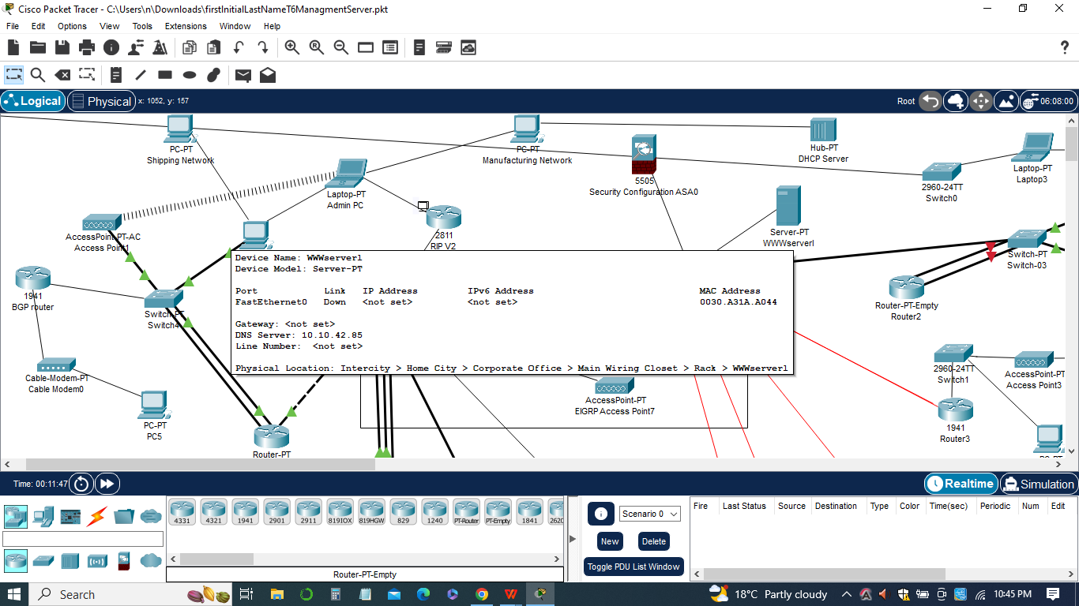

***Ping Testing***

1. The Workstation window is used to execute ping commands from a workstation located on Switch-01 in the main location.
2. Ping commands are sent to various network devices, such as routers, servers, and other workstations, to test their reachability and measure the response time.
3. The pings are performed using the device names or IP addresses, allowing for both name-based and IP-based testing.
4. The purpose of ping testing is to verify that the network devices are accessible and responsive, ensuring proper connectivity within the network.

***Verification of VPN Connectivity***

1. The Workstation window is also utilized to verify the connectivity between the VPN endpoints.
2. Ping commands are executed from the workstation to the routers participating in the VPN setup, such as the Main-Office-VPN-Router and the NewLocation routers.
3. These ping tests ensure that the VPN tunnels are successfully established, allowing secure communication between the different locations.
4. The results of the ping tests, including successful pings and response times, are documented and analyzed to validate the VPN connectivity.

***Screenshots and Documentation***.

The Workstation window provides a convenient interface for executing ping commands and verifying the connectivity and functionality of network devices and VPN connections. By conducting ping tests and capturing screenshots, network administrators can ensure that the network components are properly configured and functioning as expected.

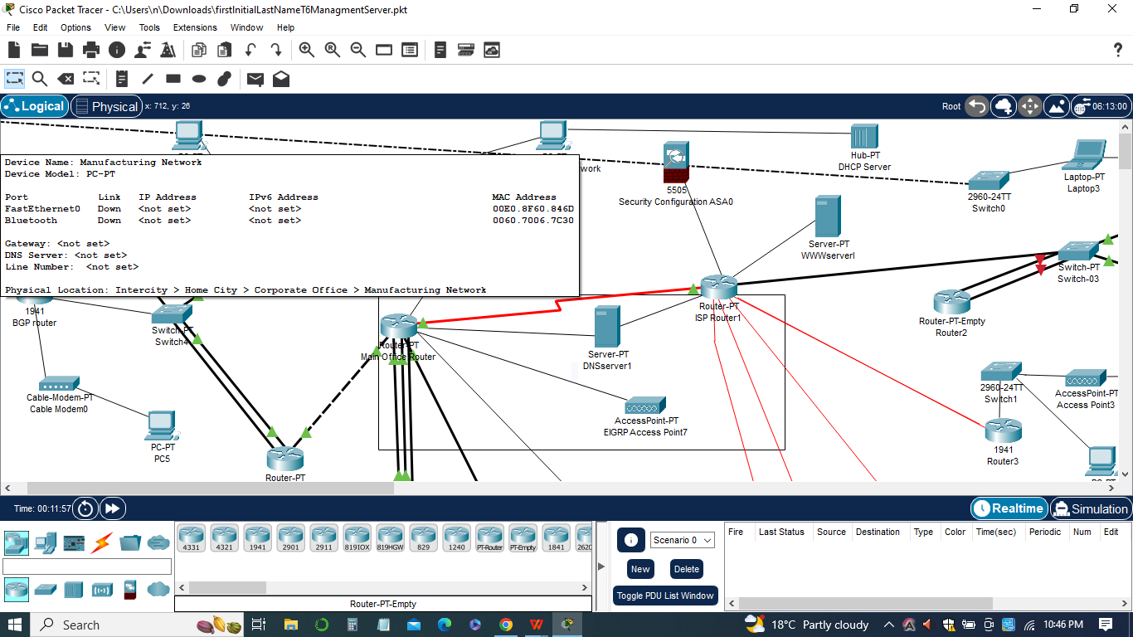

**Packet Tracer**

The Packet Tracer is a powerful network simulation and visualization tool developed by Cisco Systems. It allows users to create, configure, and simulate complex network topologies, providing a virtual environment to test and troubleshoot network designs without the need for physical equipment. Here are the key aspects of Packet Tracer:

***Visualization and Documentation***

Packet Tracer offers a visual representation of the network topology, making it easier to understand and communicate complex network designs.

Users can capture screenshots of the network topology, device configurations, and simulation results to document the network setup and changes.



The screenshots can be included in reports or presentations to illustrate the network design and its functionality.Packet Tracer is a valuable tool for network engineers and administrators to design, configure, and test network solutions. It allows for efficient network modeling, troubleshooting, and documentation, enabling users to gain hands-on experience in network design and operations without the need for physical hardware.

**Conclusion**

In conclusion, the use of Packet Tracer in this network configuration and management assignment has provided a comprehensive platform for designing, implementing, and testing various network components and features. The tool has allowed us to create secure and efficient network infrastructures by incorporating security measures such as ACLs, VLANs, port security, interior gateway protocols, and NAT/PAT. Additionally, we have successfully integrated important services like DNS, WWW, FTP, tftp, and SNMP to enhance network functionality and management.

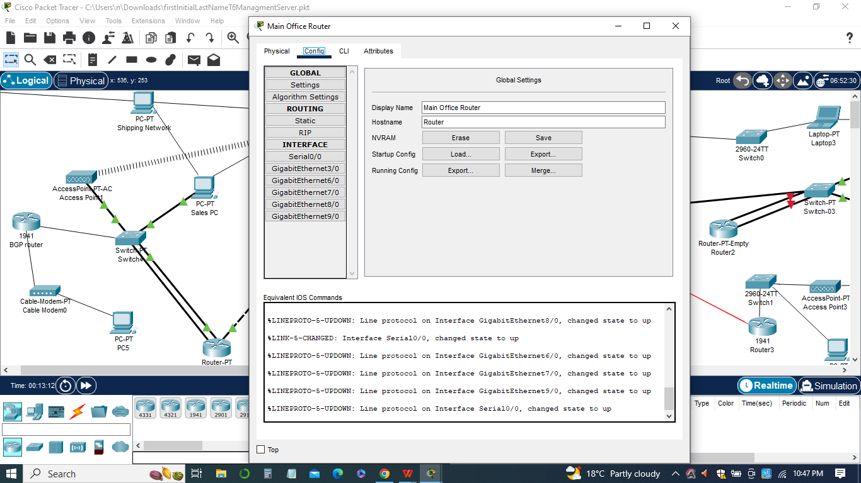

Through the simulation capabilities of Packet Tracer, we were able to visualize the network topology, configure devices, and simulate network behavior, enabling us to identify and resolve any issues or conflicts that arose during the configuration process. The ability to conduct pings, capture screenshots, and generate reports has facilitated effective network monitoring, troubleshooting, and documentation.

By providing a virtual environment for network experimentation, Packet Tracer has proven to be a valuable tool for learning and practicing network concepts. It has enabled us to gain practical experience in network design, configuration, and management without the need for physical equipment.

In sum, the use of Packet Tracer has greatly contributed to the successful implementation of secure and efficient network solutions. It has empowered us to make informed decisions, ensure network reliability, and optimize network performance. With the knowledge and skills acquired through this assignment, we are well-equipped to tackle real-world networking challenges and contribute to the successful operation of complex network environments.